狮舞弄清韵
Arise, You Lion of Glory!
为琵琶及华乐团⽽作
for Pipa and Chinese Orchestra

冯迪伦
Fung Dic-lun Gordon

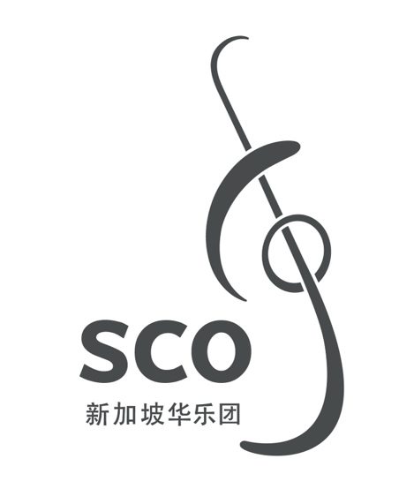

00/000
狮舞弄清韵
Arise, You Lion of Glory!
为琵琶及华乐团⽽作
for Pipa and Chinese Orchestra

冯迪伦
Fung Dic-lun Gordon

(2015)

12'

狮舞弄清韵
Arise, You Lion of Glory!

ISMN

Copyright © Singapore Chinese Orchestra Co. Ltd. All rights reserved.

版权所有, 未经许可, 不得以任何形式印刷、复制、扫描或发行。
Unauthorised printing, reproduction, scanning or distribution is strictly prohibited
without the express permission of the copyright holder.

印刷于新加坡。
Printed in Singapore.

新加坡华乐团有限公司
珊顿道7号
新加坡大会堂
新加坡邮区 068810

Singapore Chinese Orchestra Co. Ltd.
7 Shenton Way
Singapore Conference Hall
Singapore 068810

网站 Website: www.sco.com.sg
电邮 Email: aa@sco.com.sg
电话 Telephone: (65) 6557 4026
传真 Fax: (65) 6557 2756
传Biography
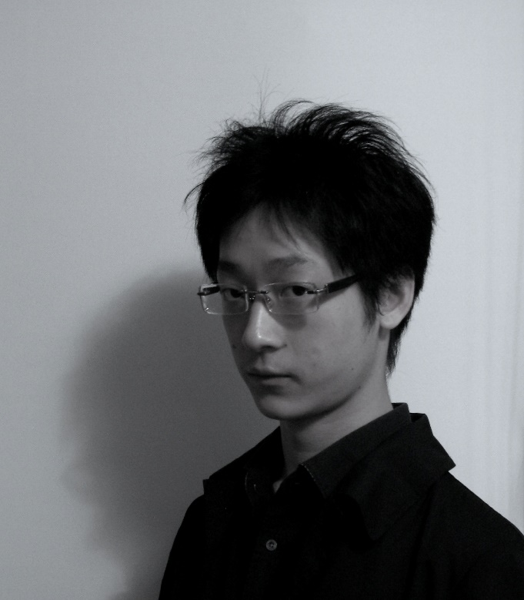
冯迪伦现于香港大学随陈庆恩教授研修作曲及攻读博士学位，并已完成硕士及学士学位(甲等荣誉 主修音乐)。
他自幼接触华乐，其后兴趣更引申至各类民族音乐。擅长为民族乐器及西洋乐器的混合配器，以及非传统配器谱写。冯氏曾获多项国际奖项：萨亚诺娃国际作曲比赛第二奖(2014)、阿特拉斯乐队作曲比赛荣誉奖(2014)、第十届卢森堡小交响乐团第四奖(2013)等。其作品曾于国际及本土音乐会上演出，包括克罗地亚、德国、荷兰、美国，俄罗斯、南韩及印度尼西亚等。
冯迪伦的作品曾被管子演奏家郭雅志、四击头、Ensemble Gending、HRT Tamburitza Orchestra、Atlas Ensemble、International Ensemble Modern Academy、香港创乐团、香港中乐团、卢森堡小交响乐团及Ensemble Proton Bern演奏。冯氏亦获邀为2015年米兰世博的「Feeding Music」计划谱写新曲。

Fung Dic-Lun is a PhD student (Music Composition) under the supervision of Prof. CHAN Hing-yan at the University of Hong Kong, where he received his M. Phil., and B. A. degree (Music – First Class Honors).
Fung has exposed to Chinese music since young, and his interest further expands into ethnic music. Being well-known for composing with mixed use of ethnic and Western instruments, and unconventional instrumentations, he has achieved several international awards: 2nd prize in Sayat Nova International Composition Competition (2014), honourable mention in Atlas Ensemble Composition Competition (2014), 3rd runner-up in the 10th Luxembourg Sinfonietta International Composition Prize (2013), etc. His works are heard in both international and local concerts, including Croatia, Germany, the Netherlands, U. S. A., Russia, South Korea, and Indonesia; also, in renowned festivals ISCM – WMD and International Gaudeamus Music Week.
Fung's works have been performed by guanzi virtuoso Guo Ya-zhi, 4 Gig Heads Percussion Group, Ensemble Gending, HRT Tamburitza Orchestra, Atlas Ensemble, International Ensemble Modern Academy, Hong Kong New Music Ensemble, Hong Kong Chinese Orchestra, Luxembourg Sinfonietta, and Ensemble Proton Bern. As the only composer from Hong Kong, FUNG is invited to write a new work for EXPO Milano 2015's project "Feeding Music."

乐曲介绍Synopsis
广东的南狮技艺精湛，高超的桩功更引人屏息。此曲就以狮艺作为背景题材，并以音乐来描绘狮艺中的不 同元素。 全曲旋律素材皆来至广东音乐《醒狮》一曲。经拆解后再以华乐中传统的作曲方式，「放慢加花」 及「旋律润饰」等手法，来重构及谱写乐段。当中亦以琵琶的传统曲式作为框架。揉合了文曲及武曲的色 彩之余，全曲也有着「起、承、转、合」的结构，务求将华乐中不同的元素共冶一炉。全曲共分十二段：初醒、 点睛、出洞、上山、巡山、舞柱、上桩、越桩、采青、叩别、升天、回吼。此作品荣获2015年新加坡国际华乐 作曲大赛创作大奖第一奖。

The traditional Cantonese lion dance is well known for its sophisticated and technical demanding gestures. This composition draws inspiration from this gorgeous tradition, using musical materials to depict various elements in the lion dance. The melodic materials are derived from the Cantonese tune Singsi (literally "Awakening of the Lion/Lion Dance"). The original melody is segmented. Through the traditional Chinese composing technique “slowing down and adding flowers,” and "melodic decoration," the new materials are constructed. This composition closely follows the structure of a traditional pipa piece. Apart from having flavours from both wenqu and wuqu, the musical flow follows a "qi – cheng- zhuan – he" structure, hence stylistically and skillfully created an eclectic piece with various Chinese idioms. There are twelve poetically named sections that made references to the lion dance. This piece won the First Prize at the Singapore International Competition for Chinese Orchestral Composition 2015.

编制Instrumentation
梆笛 Bangdi I*, II
*I兼奏小笛 *I doub. Xiaodi
曲笛 Qudi
新笛 Xindi I, II
高音笙 Gaoyin Sheng I, II
中音笙 Zhongyin Sheng I, II
低音笙 Diyin Sheng
加键高音唢吶 Keyed Gaoyin Suona I, II
中音唢吶 Zhongyin Suona
低音唢吶 Diyin Suona
中音管 Zhongyin Guan
低音管 Diyin Guan
倍低音管 Beidiyin Guan

扬琴 Yangqin (2)*
琵琶 Pipa (4)
高音阮 Gaoyin Ruan (2)
中阮 Zhongruan (4)
大阮 Daruan (2)
古筝 Guzheng

定音鼓 Timpani
7 打击乐 Percussion:
I: 管钟 Tubular bells, 风锣 Fengluo, 木琴 Xylophone, 颤音琴 Vibraphone
II: 云锣 Yunluo, 颤音琴 Vibraphone
III: 大堂鼓 Datanggu, 大小 Flexatone, 小/大风铃Small Windchimes
IV: 吊钹 Suspended Cymbal, 大小拍颤器 Large & Small Vibraslap, 大堂鼓 Datanggu, 小堂鼓 Xiaotanggu, 小/大玻铃 Small Glasschimes
V: 板鼓 Bangu, 弹簧鼓 Thunder tube, 拍板 Paiban, 狮钹 Shibo, 低音木鱼 Low Woodblock, 小/大木铃 Small Woodchimes
VI: 低音军鼓 Diyin Jungu, 狮钹 Shibo, 高音木鱼 High Woodblock, 狮钹 Shibo, 军钹 Junbo
VII: 拍板 Paiban, 狮吼鼓 Lion's roar, 低音大锣 Diyin Daluo, 高边锣 Gao Bianluo, 低音罄 Diyin Qing

笛子独奏 Dizi Solo

高胡 Gaohu
二胡 Erhu
中胡 Zhonghu
大提琴 Violoncello
低音提琴 Contrabass

* 括号内的数字为推荐演奏人数。Numbers in parenthesis indicate recommended amount of players.

